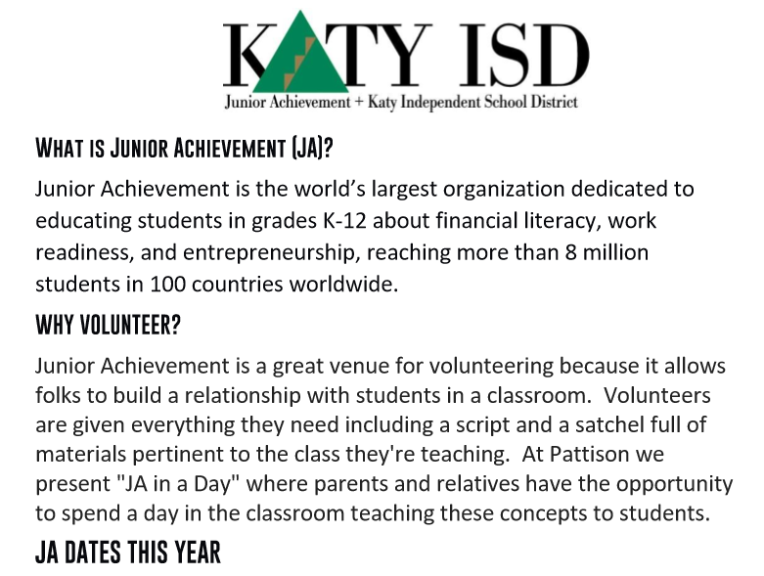
Kindergarten: October 11, 2019 | 3rd Grade: TBD
1st Grade: November 8, 2019 | 4th Grade: February 13, 2020
2nd Grade: January 10, 2020 | 5th Grade: April 13, 2020

Want to be a JA Volunteer or have questions?
Please email Emily Hafner at
Juniorachievement@pattisonpta.org

